We need to audit the DDU and DEM volumes to assess their actual usefulness and determine if any cleanup opportunities are available.

1. SNMP Base removed: - As of today DXC doesn’t support SNMP Polling.

**Before:-**

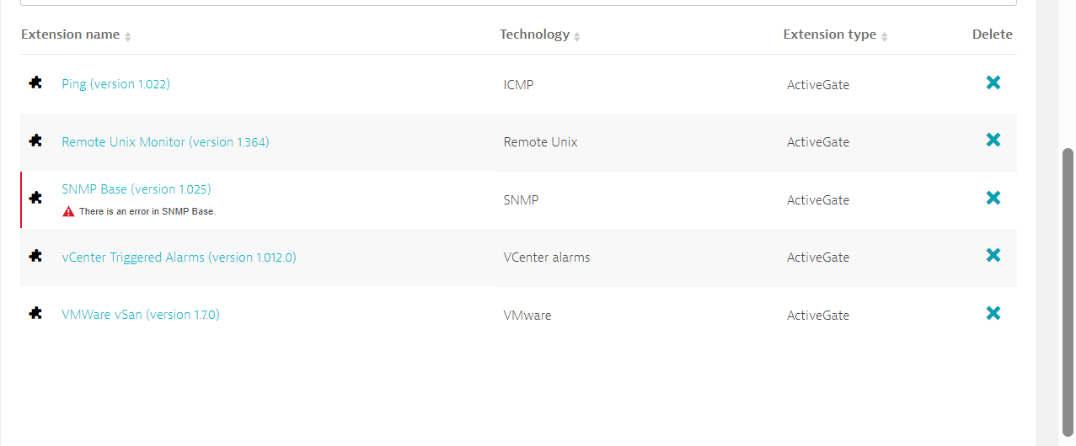

**After:-**

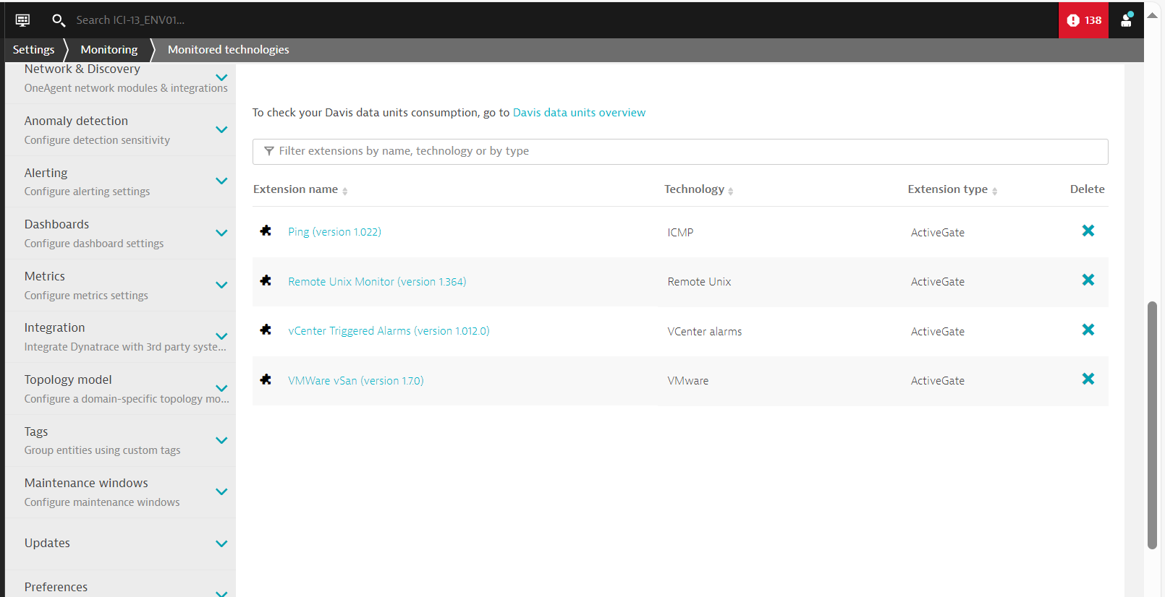

1. **Removed Generic Cisco Extension**

**Before:**

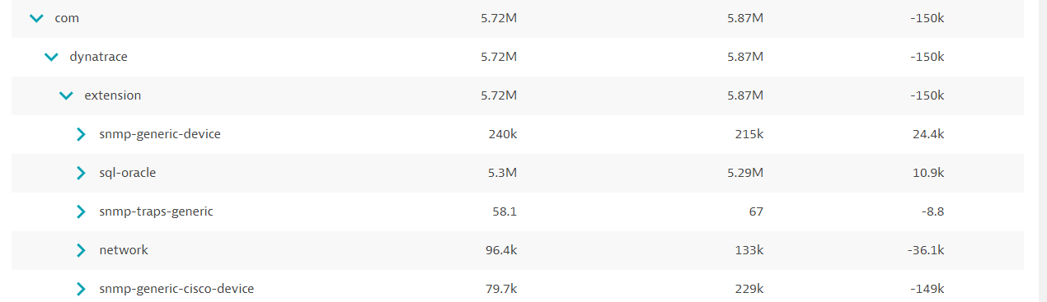

**After:**

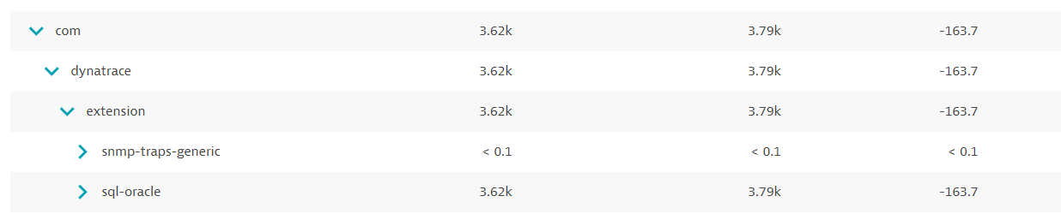

1. **Oracle DB:- Currently IMH not using Oracle DB extension in Dynatrace.**

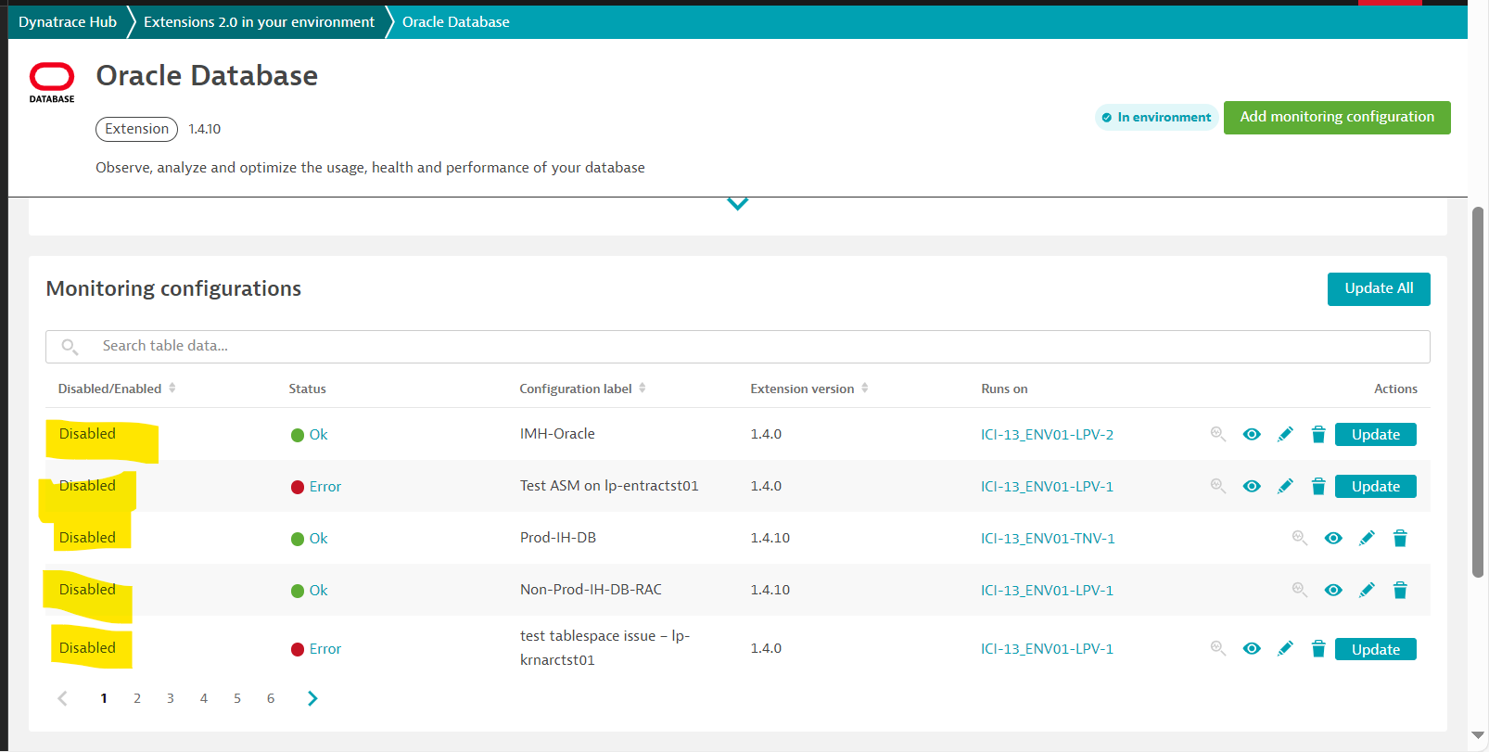

**Date:12/12/2024**

**Storage Port rule disabled as per discussion in the Storage call.**

BEFORE

============

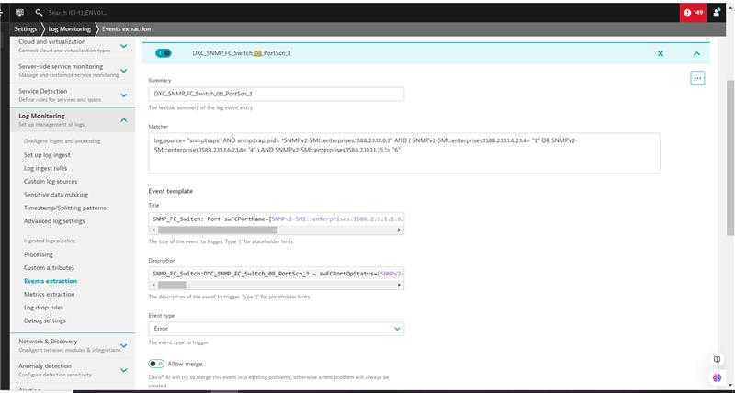

AFTER

=============

